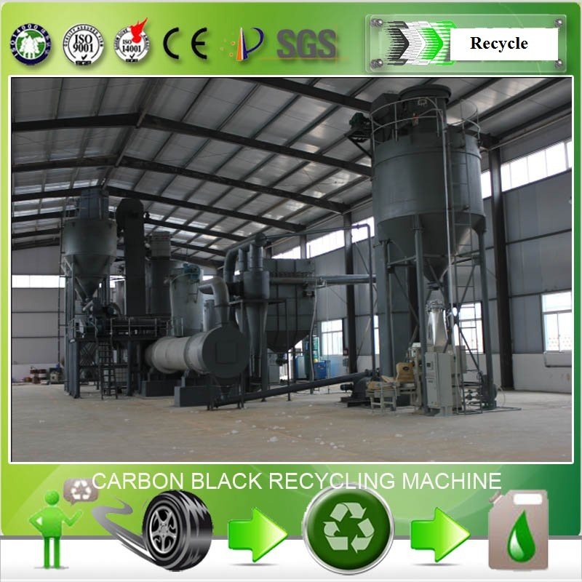

Product Features
1. The origin of ash content in carbon black
There are two origins of the ash in pyrolysis carbon black. It may come from the dust and dirt on surface of waste tires, or such organic and inorganic compounds in tires as CaCO3, Ca (HCO3)2, SiO2 and kaolin. These substances are mixed into the carbon black during the pyrolysis process of tires.

2. Removing ash from carbon black
Due to the various compositions of ash, it is a complex process to remove ash form carbon black. Moreover, as the ash is fully mixed with the carbon black, a chemical process is usually prefered instead of a physical process to reduce the as content in carbon black.

3. Process flow
Carbon black - steel wire separated - carbon black primary crushing - conveyor feeding - reacting tank - washing tank - neutralizing tank - washing - drying - fed to grinding machine with screw conveyor.

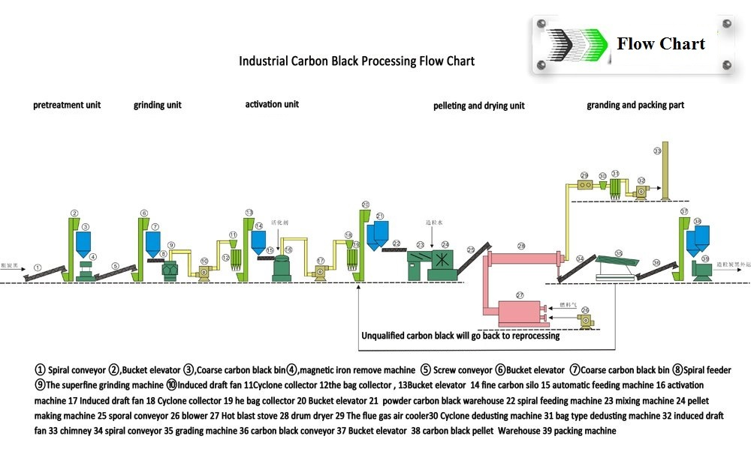

Items | Contents
Model | CB
Brand
Raw material | Pyrolysis carton black from Waste tires, waste rubber
24-hour capacity | 20-30 tones
Product | Industrial Carbon Black N220/N330/N550/N660
Power in total | 100 Kw
Life | 5 years

Product Details
Pyrolysis has been a useful procedure to treat waste-tire, which decomposes waste-tire at high temperature in the absence of oxygen. This thermal decomposition process generates pyrolysis oil, combustible gas, and char, which distribute in liquid phase, gas phase, and solid phase, respectively. Pyrolysis oil and combustible gas are fuels, while char is composed of carbon black and ash. Thus, char would be economically worthwhile to be treated before reuse. In this study, based on the resistivity difference between carbon black and ash, ash can be removed from char in the principle of electrostatic separation and thus increase the value of char. In this study, the objective was to separate ash from char by electrostatic separation process, different char including waste-tire pyrolytic char (raw char), low pressure re-pyrolytic char, ZnO-added char (12% ZnO mixed with 600 oC re-pyrolytic cahr) and man-made char (N600 carbon black mixed with 14.5% metallic oxide) were tested.

Product Description
Vehicle tires are recyclable and the various components can be separated and reclaimed for resale. Tire Recycling, referred to as Tire Pyrolysis, has become an eco-friendly method to reclaim raw materials from used or damaged tires while reducing the burden on landfills.
Carbon Black is a major component in most tires, consisting of up to thirty percent of the tire construction. It adds strength, abrasion resistance and UV protection. Carbon Black is traditionally produced through the combustion of hydrocarbons like oil. As fuel prices and demand for carbon black increases, tire producers search for alternative sources of “green” carbon black.
Pyrolysis is a process that begins with shredding old tires to extract most of the steel and fiber. The chips are then heated in an atmosphere-controlled vessel where gases are released and can be collected to be used as fuel. The solid material remaining has a high concentration of carbon black. It is then screened and run through magnets to remove any remaining fiber and steel.
At this point the material is of little value, full of agglomerates and grit. Additional milling is required to produce high quality material of commercial value.
We offer various mills especially suited for the abrasive characteristics of carbon black capability of producing a range of product particle sizes for pilot to large scale operations.

Equipment List
NO. | Name | Qty | Unit
1 | Mechanical grinder host | 2 | set
2 | Cyclone dust finished screw conveyor device | 2 | set
3 | Sieve vibrating disc | 1 | set
4 | Magnetic Separator | 1 | set
5 | Continuous mixer | 1 | set
6 | Carbon black granulator | 1 | set
7 | Semi-automatic packaging machine | 1 | set
8 | Screw Conveyor | 2 | set
9 | Electrical control cabinet | 1 | set
10 | Plumbing connections, pipes, etc. | 1 | set
11 | Test instruments, etc | 1 | set

Delivery Detail: 30days after Payment,
The warranty and after-service
1) We will supply the foundation drawings to buyer after payment.
2) We will send engineers to install the machine when the machine reach buyer's factory. The engineer, will install, guide the machine process, then training the workers for buyer.
3) We warranty the complete machine 2 years, we will maintain it for life.
4) When the machine cannot running normal, the buyer can call us, we will help buyer repair it by call, if cannot solve, we will send engineer to buyer's factory at the shortest time.
5) All after service at buyers expense.

USA Wholesalers Direct Inc.
Boston MA 02128.
United States of America

Larry A. Bridglal
Owner & CEO
Boston, MA.
Email: LBRIDGLAL@HOTMAIL.COM / usawholesalersb@aol.com

Websites:
http://usawholesalersb.wix.com/usawholesalersdirect

https://www.facebook.com/pages/USA-Wholesalers-Direct-Inc/191695774242825?ref=hl

