HA-2-18 Plastic Pyrolysis Plant
Product Features
1) Pressure gauge, alarming device, safe valve.
2) We have anti-clogging device, in case of jam, there will be automatic alaiming, automatic exhaust and automatic decompression.
3) Using 245R/345R boiler plate or 204/205 stainless. The thickness of part by fire is 14/16/18mm, other parts is 12mm.
4) Automatic welding, processing according to standard of head of pressure vessel.
5) With proprietary vacuum system, it is much safer on condition of negative pressure.

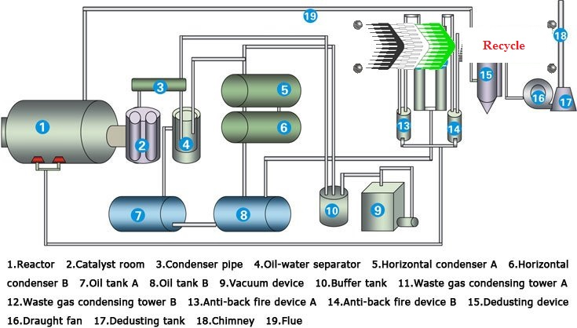

Product Specifications
Items | Contents
Raw material | Waste tyres, scrap plastic, waste rubber
Structure form | Horizontal
Model | HA-2-15 | HA-2-18 | HA-2-20
Size of reactor | D2200mm*L6000mm | D2600mm*L6000mm | D2600mm*L6600mm
24-hour capacity | 5 tones | 8 tones | 10 tones
Operating pressure | Constant pressure
Heating material | Coal, charcoal, fuel gas, fuel oil
Average out-put oil rate | 50%
Material of reactor | Q245R/Q345R boiler plate
Thickness of reactor | 14mm&16mm
Rotate speed of reactor | 0.4--0.8turn/minute
Mode of cooling | Water cooling
Power in total | 4.0-8.0 Kw
Life | 5 years

Product Details
Place of Origin: Henan China (Mainland) A Joint USA Company.
Model Number: HA-2-18
Type: Plastic Recycling Machine
Reactor Material: Q245 R boiler steel
Reactor Size: 2600*6000mm
Reactor Thickness: 14mm & 16mm
Raw Material: Waste Plastic
Capacity: 8 Tons per day
Power: 2.2*2KW
Plant Weight: 30tons
Oil Percentage: 55%-65%
Cooling Form: Water cooling
Noise dB(A): ≤85
Operation Pressure: Normal pressure
Final Product: crude oil
Auxiliary Product: good carbon black
Fuel: Coal, wood, waste gas
The Perfect Solution (Pyrolysis Process)
Pyrolysis is the decomposition of organic compounds under oxygen free (anaerobic) atmosphere that produces gas, oil, carbon black and steel. Efficient industrial Pyrolysis is a process to treat the rubber and industrial plastic wastage as well.

As a result of pyrolysis of wastage tires one obtains:
FUEL OIL (55% to 65%)
The main oil product produced by our recycling application is the fuel oil that is wide used for industrial and commercial purposes. The oil has 40% to 45% of the amount of recycled scrap tires, which will be carried with licensed tanker trucks.
CARBON BLACK (30% t0 35%)
Carbon Black is the main product recycled by Pyrolysis technology. The amount of recycled carbon black is 30% to 35% (depending on the type of tires) of the total amount of scrap tires recycled in the system. Carbon black is used as raw material or main ingredient in many industries and the chemical structure of carbon black strengthens, lengthens the endurance, and improves the coloring features of the materials.
Carbon black produced by Pyrolysis process (CBp) is more economical compared to carbon black produced primarily from petroleum and is more price-efficient to be used as an ingredient in the industries listed;
Electric cable jacketing
Conveyor band
Carrier Bands
Hose and doormat
Black nylon bag
Rubber additive
Automotive spare parts
Heat isolation
Black colorant in rubber materials
Plastic pipes
Industrial rubber products
Fire fighting
GAS (10% to 12%)
Non-Condensable gases arise during the pyrolysis process. There are some advantages such as ...
It has higher calorific value as compared to natural gas.
It can be replaced where natural gas and propane are stored.
The high energy gas may be utilized as a source of energy for the Pyrolysis process.
The amount of gas generated in the system is 12% to 15% of the total amount of recycled tires and considering the 10 ton scrap tire/day recycling capacity, the facility generates 1200 -1500 m3/day gas, which has an enormous energy potential when evaluated.
Product Description
PYROLYSIS SYSTEM
(1)Feeding-in system:
The raw material can be waste tires, rubbers or plastic. If your raw material is plastic, we suggest that you use the auto feeder. If your raw material is waste tires, we suggest that you use belt conveyor.
(2)Pyrolysis system:
The reasonable thickness, it is easy to heat and easy to be cool down.
(3)Heating system:
There are various kinds of fuel, such wood, charcoal, coal, LPG etc.
(4)Deducting system:
They usually have one or two equipment’s for deducting, we the three, desulfurization scrubber, water film cyclone and the advanced bag deduster.
(5)Impurities removing system:
There are two devices for removing the impurities from the oil gas, one is gas separate tank, the other is depositing tank.
(6) Cooling system:
We have the new design for the cooling system; it has better cooling effect and high oil yield.
(7)Oil Store system: For store the oil.
(8)Waste gas recycling system:
It is also named water seal, it has two effects, and one is for the gas separate tank, the other is depositing tank.
(9)Carbon black discharging system:
The carbon black is coming out automatic; there also has a screw conveyor for removing the carbon black.

Packaging & Delivery
LJ-2200*6600: two 40HQ containers LJ-2600*6600: one 40HQ container and one 40FR container (open container) LJ-2800*6600: one 40HQ container and one 40FR container (open container)
Delivery Detail: 30days after Payment,
The warranty and after-service
- We will supply the foundation drawings to buyer after payment.
- We will send engineers to install the machine when the machine reach buyer's factory. The engineer, will install, guide the machine process, then training the workers for buyer.
- We warranty the complete machine 2 years, we will maintain it for life.
- When the machine cannot running normal, the buyer can call us, we will help buyer repair it by call, if cannot solve, we will send engineer to buyer's factory at the shortest time.
- All after service at buyers expense.

Contact:

USA Wholesalers Direct Inc.
Boston MA 02128.
United States of America

Larry A. Bridglal
Owner & CEO
Boston, MA.
Email: LBRIDGLAL@HOTMAIL.COM / usawholesalersb@aol.com

Websites:
http://usawholesalersb.wix.com/usawholesalersdirect

https://www.facebook.com/pages/USA-Wholesalers-Direct-Inc/191695774242825?ref=hl

