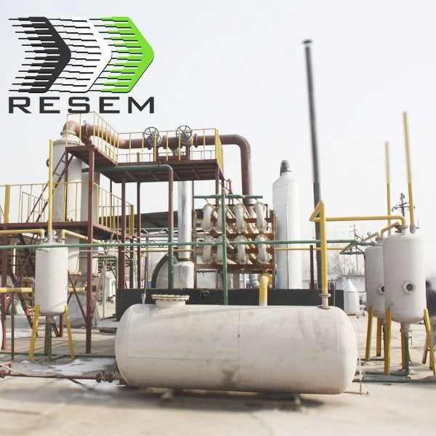
Item No.: 2HA-35-PT
Base on the latest technology and decades of years’ producing experience, RESEM designed HA-PT series pyrolysis plant. HA-PT series has completely overcome the vertical flat bottom cracking processor problems of uneven heating, easy to fracture and lower yield. Its unique Oil tank & Spray cooling system makes HA-PT series widely used in pyrolysis industry.

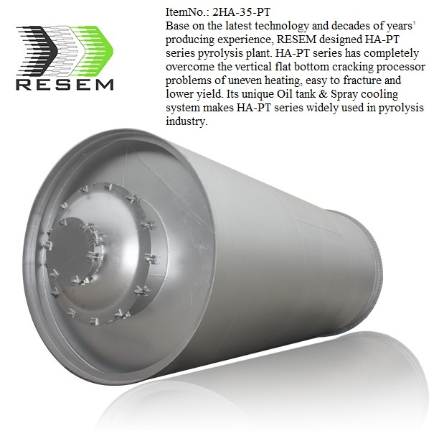

Item No.: 2HA-35-PT
Base on the latest technology and decades of years’ producing experience, RESEM designed HA-PT series pyrolysis plant. HA-PT series has completely overcome the vertical flat bottom cracking processor problems of uneven heating, easy to fracture and lower yield. Its unique Oil tank & Spray cooling system makes HA-PT series widely used in pyrolysis industry.

FUEL OIL (40% to 45%)
The main oil product produced by our recycling application is the fuel oil that is wide used for industrial and commercial purposes. The oil has 40% to 45% of the amount of recycled scrap tires, which will be carried with licensed tanker trucks.

CARBON BLACK (30% t0 35%)
Carbon Black is the main product recycled by Pyrolysis technology. The amount of recycled carbon black is 30% to 35% (depending on the type of tyres) of the total amount of scrap tyres recycled in the system. Carbon black is used as raw material or main ingredient in many industries and the chemical structure of carbon black strengthens, lengthens the endurance, and improves the coloring features of the materials.

STEEL WIRE (10% to 15%)
Tires contain steel wires and the amount range of 10% to 15% of the total tire wastage. All of the steel present in the tire can be detached after the Pyrolysis recycling process is completed. Valuable steel wires are pressed and sold to steel and scrap dealers.

GAS (4% to 10%)
Non-Condensable gases arise during the pyrolysis process. There are some advantages such as ...;
- lt has higher calorific value as compared to natural gas.
- It can be replaced where natural gas and propane are stored.
- The high energy gas may be utilized as a source of energy for the Pyrolysis process.
- The amount of gas generated in the system is 12% to 15% of the total amount of recycled tires and considering the 10 ton scrap tire/day recycling capacity, the facility generates 1200 -1500 m3/day gas, which has an enormous energy potential when evaluated.

Safe:
- We use auto welding machine to make the reactor, which has a long life for about 5 years.
- Professional heating treatment and x-ray detection chamber for welding seam.
- With professional thermometer, professional pressure gauge and safety valve.
- One water sealing tank to stop the fire coming back to the oil tank.
- Three temperature meters and three safety valves on the reactor door, the oil separator tank, the water sealing tank.
- One central control cabinet, giving alarms when temperature or pressure has something wrong. If nobody releases the gas for long time after the alarm, the safety valve will release itself to make sure of the safety.

Energy saving
- Well sealing for heating system, no gas leak and saving fuel.
- The exhaust gas will be recycled for reactor heating.
- Continuous feeding with automatic feeder, no gas leak.

Environmental friendly:

For the waste gas:
The gas from reactor: This kind of gas is produced in reactor which contains Sulfur dioxide. We can use Emission Controller to process this kind of gas and then discharge it.

For the waste water:
- Only little waste water will be produced during the production, normally we add some Alkaline solution, but that is the simple solution.
- For better results, we could add some Calcium carbonate, then we will get the Plaster, it can be sold as Building Materials. Also, we could add Sodium hydroxide, then we will get Sodium sulfite

Technical Data:
Model | 2HA-35-PT
Reactor Material | Q245 R boiler steel
Reactor Size | 2600*6600mm
Reactor Thickness | 16mm
Raw Material | Waste plastic, tires
Capacity | 20 Tons per day
Power | 30KW
Plant Weight | 35tons
Oil Percentage | 45%-50%
Cooling Form | Water cooling
Noise dB(A) | <85
Operation Pressure | Normal pressure
Final Product | crude oil, carbon black, steel(tires), gas
Fuel | Coal, wood, waste gas, oil
Warranty time | 12 months

Pyrolysis plants are widely used in various processing of waste into energy. The raw material can be waste tires, waste plastic, waste rubber, oil shale, oil rock, etc. After pyrolyzing, the waste would transfer into fuel energy.

Delivery Detail: 30days after Payment,
The warranty and after-service
- We will supply the foundation drawings to buyer after payment.
- We will send engineers to install the machine when the machine reach buyer's factory. The engineer, will install, guide the machine process, then training the workers for buyer.
- We warranty the complete machine 2 years, we will maintain it for life.
- When the machine cannot running normal, the buyer can call us, we will help buyer repair it by call, if cannot solve, we will send engineer to buyer's factory at the shortest time.
- All after service at buyers expense.

Contact:

USA Wholesalers Direct Inc.
Boston MA 02128.
United States of America

Larry A. Bridglal
Owner & CEO
Boston, MA.
Email: LBRIDGLAL@HOTMAIL.COM / usawholesalersb@aol.com

Websites:
http://usawholesalersb.wix.com/usawholesalersdirect

https://www.facebook.com/pages/USA-Wholesalers-Direct-Inc/191695774242825?ref=hl

