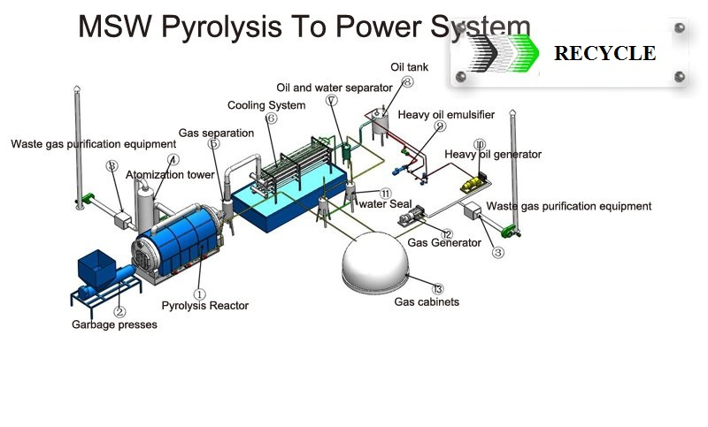
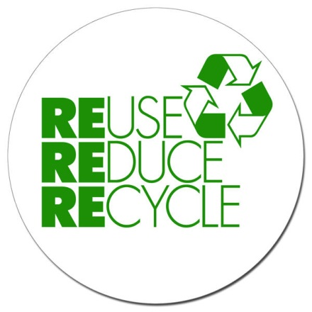

Product Features:
MSW pyrolysis to power system
Provides 100% scrap tire, scrap plastic, waste rubber recycling,
(No waste left after the process is completed),
Does not use any chemical ingredients in the process (environment friendly),
Does not cause air, soil and water pollution
Creates economically valuable products out of waste (all of the products are industrial raw materials that have market values),

Product Specifications:
Items | Contents
Raw material | Waste tyres, scrap plastic, waste rubber
Structure form | Horizontal
Model | HA-20-PT | HA-30-PT | HA-35-PT | HA-40-PT | 2HA-35-PT
Size of reactor | D2200mm  L6000mm | D2600mm  L6000mm | D2600mm  L6600mm | D2800mm  L6000mm | D2600mm  L6600mm
24-hour capacity | 5 tons | 8 tons | 10 tons | 12 tons | 20 tones
Operating pressure | Constant pressure
Heating material | Coal, charcoal, fuel gas, fuel oil
FUEL OIL | 45-50%
CARBON BLACK | 30% t0 35%
STEEL WIRE | 10% to 15%
GAS | 10% to 12%
Material of reactor | Q245R/Q345R boiler plate
Thickness of reactor | 14mm&16mm
Rotate speed of reactor | 0.4--0.8turn/minute
Mode of cooling | Water cooling
Power in total | 22-30Kw
Life | 5 years

Product Details:

Pyrolysis process is the thermal decomposition of organic materials in an oxygen-free environment and is an endothermic reaction. It requires an input of heat energy, pressure and pre-determined temperature depending on the organic material to be paralyzed.

Pyrolysis process has phases and in each phase different decompositions originate therefore different products (steam, gas, oil, etc.) are obtained. Phases of the process are determined by the process temperature; pressure, duration, and the variety of organic materials to be processed (scrap tire, plastic bottles, medical waste, etc.),

Product Description after the cycle:

Finally packaging takes place; Steel wires are stored in waste steel gathering area,

The outcome of pyrolysis process depending on the type and amount of waste tire is as follows:

40%-60% fuel oil

35%-45% carbon black

7%-8% gas

All by products of the recycling process can be sold for industrial refining, gas and fuel oil for sale or direct use.

Advantages:

Conversion of up to 100% of waste
No Greenhouse and other harmful gas emission into the atmosphere
No toxic waste to dispose of
No dioxins in the off-gas and the solid residue
Reduced public health risk
Simultaneous treatment of various types of waste materials
Reliable energy source, high energy output
High conversion efficiency
Carbon credits production
Low capital and operation costs
Low energy consumption (as compared to the alternative management scenarios)

Municipal Solid Waste (MSW) Pyrolysis System
MSW accounts for over 4 billion tons of waste annually worldwide. Cost-effective and sound municipal waste management is a pressing need in major population areas with huge volumes of waste and few disposal sites. MSW treatment bottlenecks are mainly associated with the mixed composition of the waste stream that is difficult to process effectively and safely using many applicable technologies. Our Waste Conversion Pyrolysis systems can handle various materials mixed together in everyday MSW streams, including textiles, leather, rubber and plastic goods, plastic bottles, varnish-and-paint waste, wood waste, paper, cardboard, kitchen waste, etc. and convert them to valuable by-products on a continuous basis, with no harmful emissions to the environment..

Pyrolysis of waste is the state-of-the art process providing destructive decomposition of waste materials in the absence of oxygen. Its combustion-free methodology allows us to eliminate residual and fly ash emission into the environment. Our leading edge design and structure solutions provide the extraction of maximum energy potential contained in the waste materials in the form of high calorific gas, without any liquid tar fractions and with only a small amount of solid residue being formed. This is the only system to provide complete molecular decomposition and destruction of dioxins and furans, allowing for the most environment-friendly approach to waste treatment and commercial use of the solid residue.

Our conversion technology provides continuous treatment of waste materials of various origins with no harmful residues while generating electricity or steam for the surrounding communities and industrial application.

Delivery Detail: 30days after Payment,

The warranty and after-service

1) We will supply the foundation drawings to buyer after payment.
2) We will send engineers to install the machine when the machine reach buyer's factory. The engineer, will install, guide the machine process, then training the workers for buyer.
3) We warranty the complete machine 2 years; we will maintain it for life.
4) When the machine cannot running normal, the buyer can call us, we will help buyer repair it by call, if cannot solve, we will send engineer to buyer's factory at the shortest time.
5) All after service at buyers expense.

Contact:

USA Wholesalers Direct Inc.
Boston MA 02128.
United States of America

Larry A. Bridglal
Owner & CEO
Boston, MA.
Email: LBRIDGLAL@HOTMAIL.COM / usawholesalersb@aol.com

Websites:
http://usawholesalersb.wix.com/usawholesalersdirect

