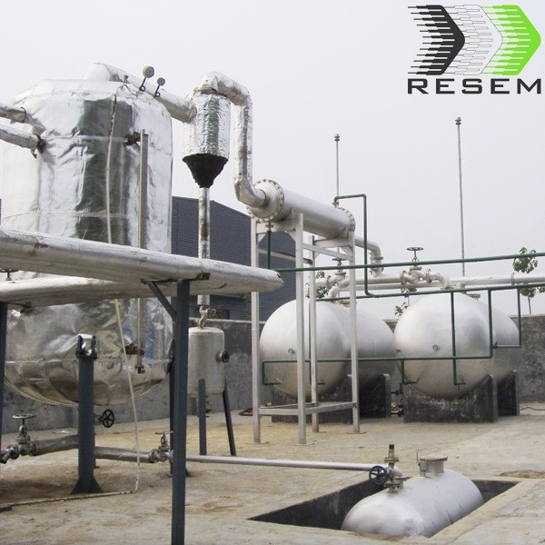

HJ-D-10 Distillation Plant
Item No.: HJ-D-10

HJ-D Oil Distillation is used for separating various oil to obtain the diesel and gasoline, Unique design and outstanding functions can help customer create more profit. This equipment is matched with pyrolysis plant. It is widely applied in waste oil management industry.

Safety:
Safety is the most important factor in the whole process. We had successfully researched some safety devices which ensure the machine can work safely.
- Safety valves, alarming device and the pressure gauge etc.
- We also have oil-water separator which can stop the oil gas recycle to the reactor, which could avoid the accident.
- High degree of automation: feed the waste oil, crude oil automatically ,to pump oil automatically.

Energy saving:
- Well sealing for heating system, no gas leak and saving fuel.
- Continuous feeding with automatic feeder, no gas leak.
- Recycling of exhaust gas and scientific fire channel design can save energy and thereby reducing costs.

Environmental friendly:
- The whole process is all sealed, won’t release any gas harmful to human and environment.
- Well water de-dusting system can avoid black smoke.

Model | HJ-D-10
Raw Material | waste engine oil /tire oil/fuel oil/ plastic oil
Structure form | vertical type
Capacity | 10 Tons
Power | 30KW
Plant Weight | 22 tons
Out-put oil rate | >80%
Operation Pressure | Normal pressure, negative
Heating system | tubular heater
Cooling Form | Water cooling
Instillation mode | With foundation
Instillation area | 1000㎡

Main Uses:
Distillation plants are widely used in transferring waste oil into diesel, gasoline, etc. The raw materials can be waste fuel oil, waste engine oil, crude oil, lubricant oil, etc. This is a sunrise project, which turn waste into energy.

The warranty and after-service
- We will supply the foundation drawings to buyer after payment.
- We will send engineers to install the machine when the machine reach buyer's factory. The engineer, will install, guide the machine process, then training the workers for buyer.
- We warranty the complete machine 2 years, we will maintain it for life.
- When the machine cannot running normal, the buyer can call us, we will help buyer repair it by call, if cannot solve, we will send engineer to buyer's factory at the shortest time.
- All after service at buyers expense.

Contact:

USA Wholesalers Direct Inc.
Boston MA 02128.
United States of America

Larry A. Bridglal
Owner & CEO
Boston, MA.
Email: LBRIDGLAL@HOTMAIL.COM / usawholesalersb@aol.com

Websites:
http://usawholesalersb.wix.com/usawholesalersdirect

https://www.facebook.com/pages/USA-Wholesalers-Direct-Inc/191695774242825?ref=hl

